As we approach the end of 2025, I want to express my sincere thanks to all of you—especially our Town & Parish Councillors—for everything you do for our community and beyond. Volunteers are not always easy to find, and yet they are so often the first people we turn to in times of need.
Thank you also to everyone who has taken the time to respond to the many consultations, hearings and attend meetings this year. We have faced a constant stream of them locally, and the level of expertise, insight, and commitment shared has been invaluable and truly appreciated. Work continues, so advance thanks to you all.
While I do try to share updates on the local community pages about items and updates that are happening locally, I’ve included a couple of information sheets once again that may be helpful during bad weather or emergencies. Please continue to follow local news and radio for the latest updates, but the details may support your planning and help you reach the right people quickly.
On a practical note, I don’t know about you, but I always keep a “power cut toolbox” ready with rechargeable torches, a phone power bank, and other essentials that can be grabbed at short notice—some ideas are listed below.
As always, please feel free to message or email if there is anything I can help with. There is no need to wait for a meeting if you need anything!
As you know, I also sit on the Suffolk Fire & Rescue steering board, it was pleasing to hear firsthand from our chief fire officer that the Inspectorate satisfied with Suffolk Fire and Rescue Service’s improvement progress.
And, as many of you know, I am honoured to serve on the fostering panels, and I have seen a notable increase in kinship carers; I would like to extend my heartfelt thanks to all who foster, support, and open their homes to children, and all those that are considering this - your contribution is life-changing, if you would like any further information, please do get in touch.
Lastly, I have received message about baby seals being attacked on local beaches. Please do keep your dogs on leads and be aware that we do have a lot more seals in the area. It would be useful for local Town and parish councils to discuss with East Suffolk Council about putting some signs up to raise awareness and give information. Like injured or deceased badgers/deer’s etc, deceased seals etc on the beach must be reported to the district council. SEAL Rescue Hotline: 01825 765546 (poster below) https://bdmlr.org.uk/bdmlr-suffolk-seal-rescue-unit
Wishing you all a very happy Christmas season and my best wishes for 2026. 🎄
Best wishes
TJ

Some Useful Information
Weather warnings
Get the latest weather warnings from the Met Office. https://www.metoffice.gov.uk/weather/warnings-and-advice/

Flood Alerts
https://www.gov.uk/sign-up-for-flood-warnings

The Orwell Bridge
Closures of the Orwell bridge are authorised by National Highways. You can find out the latest information relating to the Orwell bridge by visiting https://nationalhighways.co.uk/travel-updates/travel-alerts/

The following Twitter feeds also provide any late changes to closures and also any national or South East information:
@HighwaysSEAST
@NationalHways

Other roads in Suffolk

You can find out more information about road closures by visiting
https://one.network/

You can also get the latest information by following Suffolk Highways on Twitter

@Suff_highways

Report a Fallen Tree online.

Report a fallen or overhanging tree or hedge in Suffolk quickly and easily online. Link to Highways Reporting Tool
https://highwaysreporting.suffolk.gov.uk/?type=5&subtype=510

Please report a fallen or overhanging tree as per below::

- it poses an immediate danger to public safety - call 0345 606 6171
- on a trunk road in Suffolk - call the Highways England Information Line on 0300 123 5000

School Closures

Decisions about whether schools close are made by the schools themselves. Please check with your school directly, they should be able to give you more information.
You can also check school closures on suffolk.gov.uk.
https://www.suffolk.gov.uk/children-families-and-learning/schools/school-closures

Power cuts

For help about power cuts - call 105 or go to www.ukpowernetworks.co.uk/power-cut You can also register re priority services so please do look into this.

Suffolk Prepared

Find out more information on how you can plan ahead to deal with emergency situations from the Suffolk Resilience Forum.

Read:
Six things you can do to prepare for an emergency. A screen shot of the 6 things is below as a guide/ideas but please do go to: (https://suffolkprepared.co.uk/get-prepared/prepare-yourself/

Missed bins etc on/off street parking (signs & lines)
https://www.eastsuffolk.gov.uk/waste/waste-collection-and-disposal/bin-collection/missed-bin-collections/
https://www.eastsuffolk.gov.uk/visitors/parking/parking-problems/
Speeding & Parking that is not on/off street parking
https://www.suffolk.police.uk/
Report a pothole
You can report potholes in Suffolk quickly and easily online. Find out how to report a problem using our Highways Reporting Tool.
The Highways Reporting Tool allows you to report a new defect and monitor the status of existing reports.
Do not report a pothole online if:
- it poses an immediate danger to public safety Instead, please call 0345 606 6171.
- it’s on a trunk road in Suffolk. Instead, please call the National Highways Information Line on 0300 123 5000.
- it's on a private road.
Water leak
To report a water leak, you need to identify if it's on your property or in the street; for street/public leaks, contact Essex & Suffolk Water (ESW) Emergency on 0800 526 337, while internal leaks are your responsibility
Anglian Water
https://www.anglianwater.co.uk/your-local-area/report-an-issue
Gas https://cadentgas.com/smell-gas
If you can already smell gas and/or think there could be a leak, you should call us immediately on 0800 111 999* at any time of the day or night.
The smell of gas within your property can be alarming and should be treated seriously. There are several important things that you need to do if you smell gas; this guide will take you through the process, keeping you safe and sound should a situation arise.
Knowing how to react to a gas emergency could save your property and, more importantly, the lives of those within it. Here are some tips to help you if you smell gas either inside or outside your property. Watch the useful clips online.
Smell Gas?
0800 111 999 *
What else should you do?24/7 National Gas Emergency number
Suspect Carbon Monoxide?
0800 111 999 *
What else should you do?24/7 National Gas Emergency number

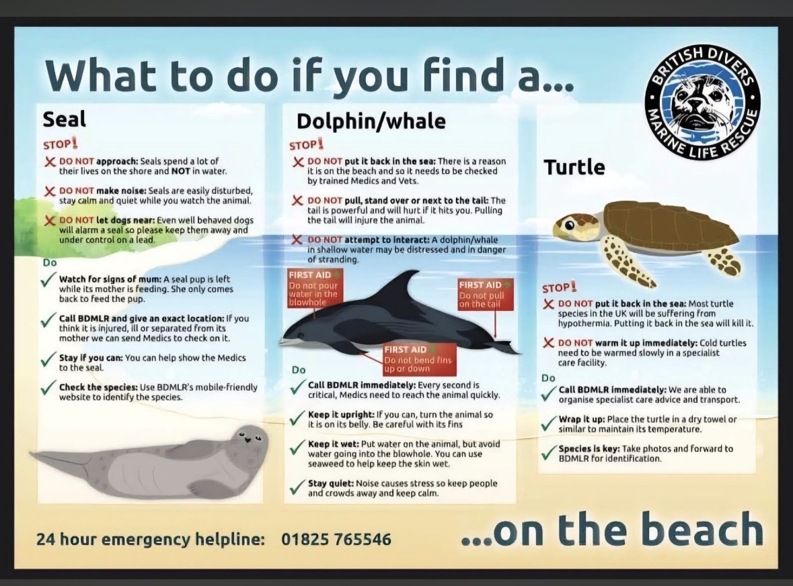

Mayoral elections

Last week, the government has announced that it wants to delay the inaugural mayoral elections for Sussex and Brighton, Hampshire and the Solent, Norfolk and Suffolk, and Greater Essex to May 2028, with areas completing the local government reorganisation process before Mayors take office. More updates to come.
You can read the government’s ministerial statement here.
https://questions-statements.parliament.uk/written-statements/detail/2025-12-04/hcws1128
Alongside unitary councils in these four county areas, county councils have been leading the development and implementation of new combined county authorities.
Suffolk Water Recycling, Transfer & Storage Project – closes soon
Essex and Suffolk Water are consulting on the following:
- The proposed locations for the Advanced Water Recycling Plant close to Lowestoft.
- The proposed pipeline corridors we have identified for the pipeline route that will transfer treated wastewater to the Advanced Water Recycling Plant, and then from there purified recycled water to be transferred to the River Waveney.
- The proposed pipeline corridors we have identified for the pipeline routes to transfer drinking water from Barsham Water Treatment Works to the proposed and existing infrastructure.
- The proposed site locations for the two service reservoirs.
These are the key elements of the Project, and we’re keen to hear what you think about them. You can do this by completing our feedback form. This, and other Project material, can be viewed in the document library.
There is a hardcopy of the proposal in the Moot Hall (please check opening times), should anyone not be able to access the online version.
This consultation closes10 December 2025.
Updates and round ups
For those that did not attend last week’s Sizewell C transport forum*, part of their update was that cones on the Wickham Bypass have been removed, but please note that there will be further works in that area coming up. There will be further traffic management regarding future works in Marlesford regarding a new footway on northbound A12 side, pedestrian crossing ducts, bat-survey etc. Again, please do keep updated via their tracker.
A recent cluster of crashes at the Friday Street/A12 junction prompted temporary traffic lights, planned sightline improvements, and a specialist safety audit. Wider Sizewell C construction impacts dominated discussion: councillors want clearer public communication, concerns persist over rerouted traffic, piling noise, and the cumulative burden of multiple major projects. Variable speed limits are being considered but may be impractical.
Several roadworks and structural issues are ongoing (Yoxford, Marlesford, Lovers Lane, Darsham crossing, Melton low spots), and bridges/culverts may need strengthening to handle abnormal loads. HGVs mostly follow approved routes, though a small number do not.
Funding for maintenance from Sizewell C and Scottish Power exists but will only release after follow-up condition surveys. Meetings between councils, parishes, and highways officers remain valuable, though staffing pressures are significant.
*2026 forum dates for your diary.
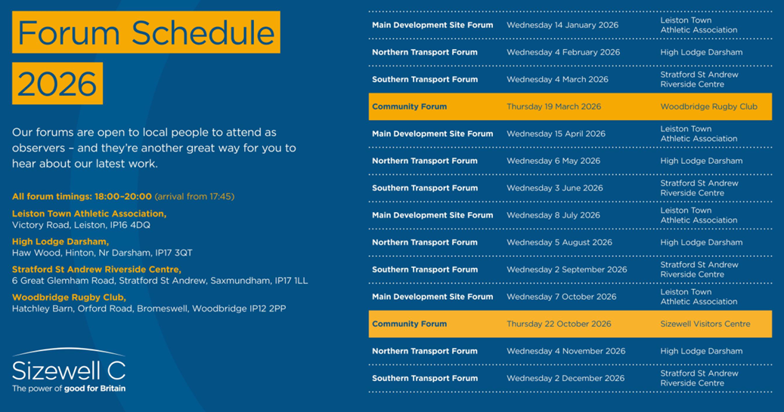
The next Community forum is very soon and Sizewell C are asking residents if they have any questions about the project that they’d like to raise through the forums, they can send these to your local parish or town council or contact their office. Residents: Please note that T&P questions are limited to 2 written questions per forum.
The papers for the 3rd December are not available yet but again, here is one link of the last transport forum (November https://www.sizewellc.com/community/forums/
Sizewell C has officially opened the first section of its Northern Park and Ride facility at Darsham, marking a significant milestone in the project’s local infrastructure development.
The partial opening will support the increasing number of people on the Sizewell C team who commute to the Temporary Construction Area and Ancillary Construction Area on the outskirts of Leiston, providing a dedicated shuttle bus to site.
By providing a convenient transport hub, the project will help to reduce traffic congestion and minimise emissions. The news follows the project’s announcement earlier this year that it was trialling hydrogen buses to transport its team to site.
The Northern Park and Ride will be fully operational by summer 2026.
You can read their full article and more updates on: https://www.sizewellc.com/news/
Please also keep yourselves updated via their tracker https://www.szcworkstracker.co.uk/
Community updates: https://www.friendsofsizewellc.com/join
New Sizewell C skills bursary open to applications
Learners in Suffolk training with Independent Training Providers can now apply for financial support through the Sizewell C Skills Fund Bursary.
Managed by the LA, the bursary is designed to remove barriers to training and employment, ensuring that local people can gain the skills needed for Sizewell C and other high-quality jobs in the county.
The fund will provide £15,000 every year for the next decade, with individual bursaries of up to £1,000 available. Applications must be supported by the learner’s training provider.
The bursary can help with essential costs such as travel, accommodation, childcare, specialist equipment, study materials, PPE or uniforms, and short upskilling courses not funded by government, like a CSCS (Construction Skills Certification Scheme) card.
Full details of eligibility and how to apply are available at https://www.suffolk.gov.uk/business/supporting-employers-training-your-workforce/sizewell-c-skills-funds
Cllr Richard Smith MVO, Suffolk County Council’s deputy leader and cabinet member for finance, economic development and skills, said:
“We want Suffolk residents to be first in line for the opportunities Sizewell C will create. This bursary will help to ensure that local people – especially those from areas with greater deprivation – have the chance to train for skilled, well-paid jobs that will strengthen our local economy and benefit communities for years to come."

The RSPB are calling for residents to write to their MP and speak up for wildlife.
https://action.rspb.org.uk/page/180990/action/1?ea.tracking.id=rspb_solus_email&utm_source=20251125_ECAM_Planning_Bill_second_email&utm_medium=email&utm_term=&utm_content=5&utm_campaign=
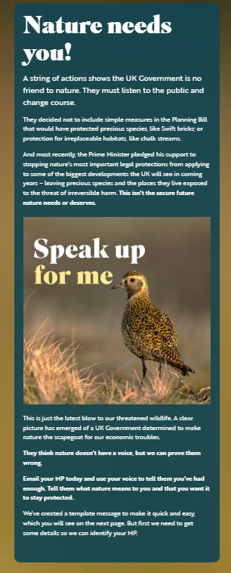

Sea Link – round up etc – ongoing
- After rounds of consultation (2022-2024), National Grid formally submitted the DCO application on 27 March 2025.
- The application was accepted for examination by Planning Inspectorate (PINS) on 23 April 2025
- Between 8 May and 23 June 2025, local authorities and interested parties had the chance to register and submit “Relevant Representations.” These have now been published.
- In July 2025, National Grid selected Sumitomo Electric Industries, Ltd. as its preferred supplier for the subsea cable — a key procurement milestone
- On 5 November 2025, the formal Examination phase began, with the first “Open Floor Hearing” held at Snape Maltings — allowing public, council and stakeholder input.
- In November 2025, Ofgem approved Early Construction Funding (ECF) for Sea Link — meaning preparations and supply-chain work could start if consent is granted.
What’s Happened Recently – again, thanks to those that contributed.
- The Examination Library and documentation have been updated to reflect “changes to the DCO application” and installation plans (e.g. subsea navigation/installation plan published September 2025). nsip-documents.planninginspectorate.gov.uk+2nsip-documents.planninginspectorate.gov.uk+2
- Local authorities, Town and parish Councils, organisations, groups and many members of the public — formally registered objections via Relevant Representations ahead of the deadline, highlighting concerns over community/landscape impacts, infrastructure and consultation process.
- In parallel, other linked projects (e.g. onshore substations or related energy-park proposals) are being reviewed for joint “Statements of Common Ground,” indicating Sea Link’s examination is part of a broader grid-upgrade context.
What’s Still Outstanding & Next Steps
- The Examination process under PINS must complete its hearings, review of representations, and all evidence submissions. That includes responses to objections, environmental assessments, and proposed modifications to the DCO.
- A final decision on the DCO is expected from the government by mid-2026.
- Disappointing to note - Even though Early Construction Funding was approved, work cannot proceed fully until consent is granted. So far, that funding mostly secures early supply-chain steps and preparatory planning.
Summary of concerns
Major concerns & objections to Sea Link
- Community, environmental and economic harm — argues that Sea Link will inflict unacceptable harm … to the communities, environment and economy of East Suffolk, beyond impacts from other infrastructure projects the area already hosts.
- Weak “need case” for the project — questions whether the reinforcement is genuinely required now: the project’s need is tied to other yet-uncertain developments (e.g. the onshore infrastructure for other energy projects), meaning the benefit may not materialise.
- Inadequate landscape, heritage and ecological safeguards — Suffolk County Council (SCC) objects to aspects such as a proposed new bridge over the River Fromus (near Saxmundham), which they consider disproportionate; they cite risk of significant adverse effects on landscape character, heritage assets (including listed buildings), environment, and inadequate mitigation capacity.
- Cumulative impact with other infrastructure projects — SCC and ESC warn that the timing of Sea Link coincides with other major schemes (subsea cables, substations, offshore wind-related infrastructure), raising serious concerns over repeated disruption, loss of amenity, repeated damage to ecology and landscape, and overloading the “tolerance” of communities and environment.
- Flawed application / procedural and documentation issues — A coalition of conservation organisations and campaign groups argues the DCO application suffers from “serious legal, procedural and environmental failings,” including inadequate ecological surveys, missing or inconsistent documentation, insufficient environmental baseline data, and flawed impact assessments.
- Insufficient consideration of alternatives — Councils say alternative routes, offshore-only options or other technical alternatives have not been properly assessed, and coordination with related projects (e.g. onshore cable corridors for other links) remains weak.

If you are not registered for general updates, you can still so this by: Visiting National Grid: Go to the official Sea Link page on the National Grid website. https://www.nationalgrid.com/the-great-grid-upgrade/sea-link
https://nationalgrid.tractivity.io/ExternalFormViewer/Form.aspx?ExternalFormID=36
- Sign Up: Use the contact section to join their mailing list for direct updates.
- Contact Details: Email: contact@sealink.nationalgrid.com or call 0808 134 9569.

NATIONAL LANDSCAPE - GRANTS
Apply now - National Landscape Community Grants 2026-27
Please share these grant opportunities via your community networks.

 | Grants across Suffolk & Essex…
Community Grants
Dedham Vale National Landscape & Stour Valley



dedhamvale-nl.org.uk/managing/grants/
 | Fund Name | Apply for £ | Apply by
 | Sustainable Development Fund –  Dedham Vale National Landscape | £6,000 | 3rd February 2026
 | Stour Valley Environment Fund | £2,500 | Rolling applications
Community Grants
Suffolk & Essex Coast & Heaths National Landscape



coastandheaths-nl.org.uk/managing/grants/
 | Fund Name | Apply for £ | Apply by
 | Sustainable Development Fund –  Suffolk & Essex Coast & Heaths National Landscape | £6,000 | 3rd February 2026
 | Galloper Wind Farm Fund | £3,000 | 9th June 2026
 | Amenity and Accessibility Fund | £3,000 | 9th June 2026

Updates for 2026-27 |  | For all grants  - The Application Form has been simplified  - There is a new Budget Form for all applicants to complete - feedback is encouraged - so please let me know if guidance is needed, if any difficulties are encountered or if you need the form in a different format.  Community and Conservation Fund – is now part of the Sustainable Development Fund  - We still welcome small grant applications to all of the community funds  - For small grant applications up to £1,000 the Sustainable Development Fund has a simplified Budget Form  Sustainable Development Fund (SDF)  - For small SDF grant applications up to £1,000 there is a simplified budget form. Complete Budget Form 1  - For larger SDF grant applications over £1,000 extra detail is needed for the project budget. Complete Budget Form 2

Other National Landscape Funding opportunities
- Natural Environment Improvement Fund – Apply now!
A £10 million fund to mitigate residual landscape and visual impacts of the Sizewell C Project, contribute to the conservation and enhancement of landscape character, enhance biodiversity, and improve habitat connectivity and resilience in the Suffolk & Essex Coast & Heaths National Landscape and its setting.
For more - follow the below link:
Natural Environment Improvement Fund – Apply now!
- Farming in Protected Landscapes funding - enquire now Alex.Dinsdale@suffolkandessex-nl.org.uk
The Farming in Protected Landscapes programme is open to all farmers and land managers (including from the private, public and charity sector) in the Suffolk & Essex Coast & Heaths National Landscape – or where activity on the ground can bring benefit to the National Landscape.
For more - follow the below links:
  - Dedham Vale National Landscape
  - Suffolk & Essex Coast & Heaths National Landscape
You can now apply for significant grant funding in both the Dedham Vale and the Suffolk & Essex Coast & Heaths National Landscapes

Inspectorate satisfied with Suffolk Fire and Rescue Service’s improvement progress
His Majesty’s Inspectorate of Constabulary and Fire & Rescue Services (HMICFRS) has confirmed it is satisfied with the progress Suffolk Fire and Rescue Service is making to address improvements identified during its previous inspection.
In a letter received this week following an October revisit, inspectors recognised early positive change across leadership, governance and organisational culture, supported by a comprehensive action plan developed with staff and representative bodies.
Inspectors also noted the significant investment and support from Suffolk County Council - totalling £1.6 million over two years, which has enabled new posts, development programmes and organisational reforms to be put in place.
While acknowledging that meaningful cultural improvement takes time, the inspectorate confirmed it is satisfied with the service’s progress to date.
Jon Lacey, Suffolk Fire and Rescue Service’s Chief Fire Officer, said:
“We welcome the inspectorate’s recognition of the progress made so far, which reflects the hard work and commitment of our staff and leaders.
“We are building a positive, inclusive and values-led culture, and while we are encouraged by this feedback, we know we are only partway through our improvement journey.
“Our focus now is on continuing to embed change, strengthening leadership behaviours, and ensuring that improvements become sustainable and consistent across the organisation.”
Since the inspection last year, Suffolk Fire and Rescue Service, has:
- Secured £1.6m investment from Suffolk County Council to support improvement.
- Recruited nine new posts, with eight further roles in progress.
- Developed a comprehensive 37-goal improvement plan addressing all recommendations.
- Introduced new governance boards and improved oversight of progress.
- Delivered leadership development, training and 360-degree feedback programmes.
- Increased staff engagement through surveys, feedback processes and enhanced internal communications.
- Commissioned external peer support and challenge to promote learning and transparency.
Councillor Steve Wiles, Suffolk County Council’s Cabinet Member for Public Health and Public Protection, said:
“It is reassuring to see the Inspectorate recognise the meaningful progress being made.
“The council’s £1.6 million investment is supporting improvements in leadership, communication and culture, and it is encouraging to see positive change emerging.
“There is more work ahead, but strong foundations have now been put in place, and we will continue supporting the service as it delivers the high standards our communities expect.”
To read the letter from HMICFRS in full, please visit: Suffolk Fire and Rescue Service: Cause of concern revisit letter - His Majesty’s Inspectorate of Constabulary and Fire & Rescue Services.

Suffolk Fostering Christmas film highlights what it means to belong
All children want is somewhere to belong – that’s the message at the heart of a short film produced by the Suffolk Fostering Service this December.
With the need to recruit more foster carers as pressing as ever, audiences will be introduced to a moving new film that captures the essence of family, tradition, and hope.
The film’s story follows a young boy as he joins his foster family in the annual tradition of selecting and decorating their Christmas tree.
Among the twinkling lights and handmade ornaments, he discovers family photographs from years past – something that leads him to reflect on his own journey and sense of belonging. Observing this, the foster carers’ daughter offers him a heartfelt gift, an act of kindness that restores his hope and affirms the warmth of acceptance.
With its poignant narrative and festive backdrop, the film is a celebration of resilience, compassion, and the enduring spirit of the festive season.
We believe every child deserves a place where they can truly belong – and it’s a responsibility we all share to make sure they’re given the very best start in life. By choosing to foster with your local council, you help keep Suffolk children close to the people, places, and communities they already call home. You can give a child a place to belong, to grow and to thrive.
Through initiatives that champion care, compassion, and opportunity, Suffolk County Council continues to work towards a future where every child feels valued and supported.
This new film serves as a reminder that belonging is at the heart of hope – and through fostering, we can help make that hope a reality.
The filming location was provided by Rougham Estate, while Offset Films produced the film.
Simon Eddell, Estate Manager at Rougham Estate, said: “It’s a small contribution, but one that we are delighted to be part of in order to raise awareness of a significant cause. We hope it helps many children.”
To find out more about fostering with Suffolk County Council, visit: www.fosterandadopt.suffolk.gov.uk
Watch 'Belong – The Christmas story of Hope':
https://www.suffolk.gov.uk/council-and-democracy/council-news/suffolk-fostering-christmas-film-highlights-what-it-means-to-belong



Further afield
Have your say on plans for key Ipswich town centre route
The public is being asked for its views on an Active Travel scheme to enhance Princes Street between Ipswich town centre and the railway station.
The proposals to enhance Princes Street. (Image: SCC)
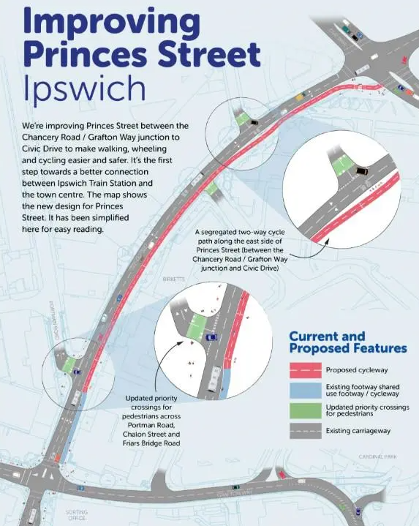
Suffolk County Council is asking residents, businesses and local groups for their views on proposals for a new cycle path along a key Ipswich town centre route.
The cycle path would be in Princes Street and would provide a continuous, high-quality route supporting active travel from Ipswich railway station to the town centre.
The council wants Princes Street to become safer, more accessible and more enjoyable for everyone to walk, wheel and cycle while ensuring those who need to travel by car can still do so easily and directly.
It has now launched a public consultation to refine and finalise the proposals, which are being funded by Active Travel England.
They are:
- A new segregated two-way cycle path along the east side of Princes Street (between the Chancery Road / Grafton Way junction and Civic Drive).
- Update to priority crossings for pedestrians across Portman Road, Chalon Street, and Friars Bridge Road.
An online survey is now underway and runs until Monday December 22.
An unmanned public display will also be available at Endeavour House in Ipswich until December 22 (10am–4pm).
Councillor Chris Chambers, Suffolk County Council Cabinet member for Sustainable Transport, said: “If you live or work in Ipswich please let us know what you think.
“We want to hear from the community not only on the proposals but what else we can do to improve the route from Ipswich railway station into the town centre to make sure that it works for everyone.
“People’s feedback is important as it helps us address local challenges and design a space that supports how they live, travel and move through where they live and work.”
This project forms part of Suffolk’s wider Local Cycling and Walking Infrastructure Plan (LCWIP) to deliver safer, greener routes across the county.
For more details go to the Princes Street Active Travel website.
Council fears Sunnica is to become a ‘Trojan horse’ for new large infrastructure projects
Developers behind the controversial Sunnica solar farm project on the Suffolk / Cambridgeshire border are seeking permission from the Secretary of State, the Rt Hon Ed Miliband MP, to make significant changes to their planning application.
Sunnica Ltd is a joint venture between Tribus Clean Energy and PS Renewables. They are hoping to extend the provision in their agreed planning permission, to secure 'future value-adding flexibility', as stated in their letter to government:
“To provide the Scheme with sufficient future value-adding flexibility in relation to adjacent land that may be subject to planning applications in conjunction with the Scheme.”
These changes would enable them to integrate future proposed developments that come forward, by allowing local planning applications to overlap with the entire boundaries of the Sunnica scheme.
It means that new, vast projects such as data centres could cover many hectares of land, on top of that covered by the already-agreed solar panels, battery storage and associated infrastructure.
A consultation on these proposed changes will begin in due course. However, while the proposal sets out a limited number of consultees, it is very important to recognise that any relevant party will be able to respond.
"It appears to me that the Sunnica solar farm is a Trojan horse - a devious way of introducing even more infrastructure into our county which is lucrative only for the developer and landowners while our communities and landscape pay a heavy price."
Councillor Richard Rout, Suffolk County Council’s Cabinet Member for Devolution, Local Government Reorganisation and NSIPs, said:
“I stand by my previous comments that Sunnica is the poorest infrastructure application that I have ever dealt with.
“In a similar vein, we now learn that they want to move the goalposts on their application, to allow them to sweep through even more potential developments associated with the scheme. For example, this could be large data centres, potentially covering even more land.
“It appears to me that the Sunnica solar farm is a Trojan horse - a devious way of introducing even more infrastructure into our county which is lucrative only for the developer and landowners while our communities and landscape pay a heavy price.
“The approach Sunnica is taking shows complete contempt for local residents and communities.
“I strongly encourage all parishes, organisations, and individuals, who believe they may be affected by the proposed changes to respond to the consultation, when it commences.”
17 November 2025: Since the publication of this news story, Sunnica Ltd has announced that it does not intend to proceed with the change concerning the 'future value-adding flexibility'. The consultation will solely focus on the amended Order Limits surrounding Burwell substation.
Please keep updated for all SCC news items and updates on https://www.suffolk.gov.uk/council-and-democracy/council-news

You would have already received this energy update, a reminder: (Nov 2025)
Local authority roles in the NSIP process During the NSIP process, the role of the county and district council is that of a statutory consultee who can try to persuade/advise, but local authorities cannot force changes upon the developer, as they are not the decision-makers. Neither the county nor the district council are responsible for designing or delivering any scheme. However, they are important stakeholders who can often shape the design and mitigation of projects. Parish and town councils hosting, or being adjacent to, proposed NSIPs are also statutory consultees. It is important for these councils to provide the local community perspective in the process, aiming to influence design, mitigation, and community benefit proposals.
Glossary • BESS = Battery Energy Storage System • DCO = Development Consent Order • DoR = Discharge of Requirement • EIA = Environmental Impact Assessment • NGET = National Grid Electricity Transmission • NGV = National Grid Ventures • NSIP = Nationally Significant Infrastructure Project • PINS = Planning Inspectorate • SALC = Suffolk Association of Local Councils • SCC = Suffolk County Council
Proposed NSIP Projects in Suffolk - Updates (Projects in Alphabetical order)
East Anglia ONE North and TWO Offshore Wind Farms (Scottish Power Renewables (SPR))
Location: East Suffolk
East Anglia ONE North and TWO are proposals to create connections to a new substation at Friston via High Voltage Alternating Current undersea and underground cables. Update (August 2025): Officers from Suffolk County Council continue to discharge requirements attached to the Development Consent Order. Construction works on the haul road are expected to commence shortly. Scottish Power Renewables have also been running workshops on the substation design for stakeholders.
More information:
• Link to East Anglia ONE North's webpage: https://www.scottishpowerrenewables.com/pages/east_anglia_one_north.aspx
• Link to East Anglia TWO's webpage: https://www.scottishpowerrenewables.com/pages/east_anglia_two.aspx
• Link to the Suffolk County Council webpage on East Anglia ONE North: https://www.suffolk.gov.uk/planning-waste-and-environment/major-infrastructureprojects-including-nsips/nsips-in-suffolk/east-anglia-one-north
• Link to the Suffolk County Council webpage on East Anglia TWO: https://www.suffolk.gov.uk/planning-waste-and-environment/major-infrastructureprojects-including-nsips/nsips-in-suffolk/east-anglia-two
• Link to the PINS webpage where all public documents relating to East Anglia ONE North can be found here: https://national-infrastructureconsenting.planninginspectorate.gov.uk/projects/EN010077
• Link to the PINS webpage where all public documents relating to East Anglia TWO can be found here: https://national-infrastructureconsenting.planninginspectorate.gov.uk/projects/EN010078
EcoPower Suffolk
Location: Mid Suffolk
An energy farm with solar PV and a co-located Battery Energy Storage System (BESS) and associated infrastructure which also includes a grid connection to the Yaxley National Grid substation. The project will consist of 600 hectares of solar panels spread across several sites, and a battery storage site to the south of Thrandeston. (No update this issue)
Update from the last issue (May 2025): The project promoter has carried out initial engagement with communities, parish councils and county councillors. An initial informal consultation with the public took take place in March - April 2025. Suffolk County Council has responded to the consultation setting out its objection to the proposals: https://www.suffolk.gov.uk/council-and-democracy/councilnews/one-week-left-to-share-thoughts-on-large-solar-farm-in-north-suffolk
EcoPower recently issued a news release stating the following: "A new liaison group with local stakeholders is being set up, including Suffolk County Council, Mid-Suffolk District Council and parish council representatives to ensure they are all kept abreast of the latest project developments."
For the full news release see https://ecopowersuffolk.com/news Statutory consultation is now expected spring 2026. For more information see https://ecopowersuffolk.com/consultation-process/ More information:
• Link to EcoPower Suffolk's website: https://ecopowersuffolk.com
• Link to the PINS webpage where all public documents relating to EcoPower Suffolk can be found: https://national-infrastructureconsenting.planninginspectorate.gov.uk/projects/EN0110019
Five Estuaries Offshore Wind Farm
Location: Off East Suffolk coast / Essex
A wind farm proposed off the East Suffolk coast, with the landing point and onshore infrastructure proposed to be in Essex. Update (August 2025): The examination into the Five Estuaries Offshore Wind Farm concluded in March 2025. Officers from Suffolk County Council attended hearings and participated in the written process, raising issues relating to landscape impact, traffic and transport, and skills and employment.
On 17 June 2025, The Examining Authority (the Planning Inspectorate) submitted a Report and Recommendation in respect of its findings and conclusions on the Five Estuaries proposals to the Secretary of State. In accordance with section 107 of the Planning Act 2008, the Secretary of State has three months to determine the application with a deadline set for the decision of 17 September 2025.
More information:
• Link to Five Estuaries' website: https://fiveestuaries.co.uk
• Link to Suffolk County Council's webpage on Five Estuaries: https://www.suffolk.gov.uk/planning-waste-and-environment/major-infrastructureprojects-including-nsips/nsips-in-suffolk/five-estuaries-offshore-windfarm
• Link to the PINS webpage where all public documents relating to Five Estuaries can be found: https://national-infrastructureconsenting.planninginspectorate.gov.uk/projects/EN010115
Helios Energy Park
Location: East Suffolk Helios is a proposed energy farm consisting of ground mounted solar PV and battery energy storage system (BESS) in the locality of the consented but as yet unbuilt substation at Friston Deloitte, acting for the applicant of the proposed Helios Energy Farm, submitted a relevant representation in response to the Sea Link proposals, which brought the scheme into the public domain.
More Information:
• Link to Helios Energy Park relevant representation to Sea Link: nsipdocuments.planninginspectorate.gov.uk/published-documents/EN020026-000593- Helios%20%20SEAL%20Link%20Relevant%20Representation%20230625_Redacted.pdf

• Link to Suffolk County Council's press release regarding the Helios proposals: https://www.suffolk.gov.uk/council-and-democracy/council-news/sea-linkpaperwork-reveals-plans-for-large-solar-farm-near-friston
LionLink
Location: East Suffolk
LionLink is the proposal by National Grid Ventures (NGV) for a subsea electricity link between Suffolk and the Netherlands, which will also connect with Dutch windfarms. (No update this issue) Update from the last issue (May 2025): In February 2025, National Grid Ventures (NGV) announced Walberswick as its preferred landfall site for the LionLink project, a proposed multi-purpose interconnector (MPI) between the UK and the Netherlands. As a result, the landfall site option north of Southwold has been discounted. NGV has also organised two community drop-in sessions and a webinar in March 2025, ahead of the statutory consultation planned for Autumn 2025. If granted development consent, NGV is now planning to have the project operational in 2032. Initial ground investigation surveys around Walberswick are ongoing.
More information:
• Link to LionLink’s National Grid website page: https://www.nationalgrid.com/national-grid-ventures/lionlink/about
• Link to Suffolk County Council's webpage on LionLink: https://www.suffolk.gov.uk/planning-waste-and-environment/major-infrastructureprojects-including-nsips/nsips-in-suffolk/lionlink
• Link to Suffolk County Council’s response to the non-statutory consultation: https://www.suffolk.gov.uk/asset-library/eurolink-non-statutory-consultation-sccresponse1.pdf
• Link to Suffolk County Council’s response to the supplementary non-statutory consultation: https://www.suffolk.gov.uk/asset-library/LionLink-Supplementary-NonStatutory-Consultation-SCC-response.pdf
• Link to the PINS webpage where all public documents relating to LionLink can be found: https://national-infrastructureconsenting.planninginspectorate.gov.uk/projects/EN020033
North Falls Offshore Wind Farm
Location: Off East Suffolk coast / Essex
A wind farm proposed off the East Suffolk coast, with the landing point and onshore infrastructure proposed to be in Essex. Update (August 2025): The examination of the North Falls Offshore Wind Farm application began on 29 January 2025 and concluded on 28 July 2025. PINS have three months to prepare their recommendation to the Secretary of State with a deadline of 28 October 2025. Officers from Suffolk County Council have attended hearings and participating in the written process, raising issues relating to landscape impact, traffic and transport, and skills and employment.
More information:
• North Falls Website: https://www.northfallsoffshore.com
• Link to the Suffolk County Council webpage on North Falls: https:/www.suffolk.gov.uk/planning-waste-and-environment/major-infrastructureprojects-including-nsips/nsips-in-suffolk/north-falls-offshore-windfarm-scottish-andsouthern-electricityrwe
• Link to the PINS webpage where all public documents relating to North Falls can be found: https://national-infrastructureconsenting.planninginspectorate.gov.uk/projects/EN010119
Norwich to Tilbury
Location: Babergh and Mid Suffolk
This project proposal by National Grid Electricity Transmission (NGET) is to construct a new 400 kV electricity transmission line between Norwich and Tilbury.
Update (August 2025): National Grid are presently consulting the Host Local Authorities on a suite of draft documents, including draft Management Plans and the draft Statement of Common Ground, to prepare these for submission. The Council will continue engagement with National Grid to refine these drafts prior to the Examination. The expectation is that the DCO application will be submitted during August 2025. PINS will have 28 days, from the date of submission, to decide whether to accept the application for examination.
More information:
• Link to Norwich to Tilbury’s National Grid webpage: https://www.nationalgrid.com/electricity-transmission/network-andinfrastructure/infrastructure-projects/norwich-to-tilbury
• Link to the Suffolk County Council webpage on Norwich to Tilbury: https://www.suffolk.gov.uk/planning-waste-and-environment/major-infrastructureprojects-including-nsips/nsips-in-suffolk/norwich-to-tilbury
• Link to Suffolk County Council's response to the Norwich to Tilbury non-statutory consultation: https://www.suffolk.gov.uk/asset-library/imported/scc-response-toeag-informal-consultation-16-june.pdf
• Link to Suffolk County Council's response to the Norwich to Tilbury supplementary non-statutory consultation: https://www.suffolk.gov.uk/asset-library/scc-responseto-norwich-to-tilbury-non-stat-con-2.pdf
• Link to Suffolk County Council's response to the Norwich to Tilbury statutory consultation: https://www.suffolk.gov.uk/asset-library/scc-response-to-norwich-totilbury-statutory-consultation.pdf
• Link to Suffolk County Council's response to the Norwich to Tilbury targeted consultation: https://www.suffolk.gov.uk/asset-library/scc-n2t-targeted-con-2025- response-with-appendix.pdf
• Link to the PINS webpage where all public documents relating to Norwich to Tilbury can be found: https://national-infrastructureconsenting.planninginspectorate.gov.uk/projects/EN020027
Sea Link
Location: East Suffolk
Sea Link is a proposal for a subsea, grid reinforcement link between Suffolk and Kent. Currently there is a proposed converter station near Saxmundham, connected by underground cables from a landing point between Aldeburgh and Thorpeness.
If the substation at Friston is not built under its existing consent as part of ScottishPower Renewables' East Anglia ONE North/TWO project, the substation will form part of the Sea Link proposals.
Update (August 2025): The Planning Inspectorate (PINs) received the DCO application for the Sea Link proposals on 27 March 2025 and accepted the application for Examination on 23 April 2025. The acceptance of the application sets out the timeline of the Examination including the Relevant Representations, where interested parties are invited to provide full details of the issues that they want to be considered by the Examining Authority. The relevant representation period was initially between 8 May to 23 June 2025; however, due to an error in publishing the applicant's notice under regulation 9 of the Applications: Prescribed Forms and Procedures Regulations 2009, a further relevant representation period was opened by the Examining Authority between 18 July and 18 August 2025 for all parties who did not submit a valid representation during the first registration period.
Representations which were received up to 23 June were published by the Examining Authority on 18 July 2025.
More information:
• Link to Sea Link’s National Grid website page: https://www.nationalgrid.com/thegreat-grid-upgrade/sea-link
• Link to Suffolk County Council's Sea Link webpage: https://www.suffolk.gov.uk/planning-waste-and-environment/major-infrastructureprojects-including-nsips/nsips-in-suffolk/sea-link
• Link to Suffolk County Council's response to the Sea Link non-statutory consultation: https://www.suffolk.gov.uk/asset-library/sea-link-scc-response-non-statutoryconsultation.pdf

• Link to Suffolk County Council's response to the Sea Link statutory consultation: https://www.suffolk.gov.uk/asset-library/scc-sea-link-statutory-consultationresponse.pdf
• Link to Suffolk County Council's response to the Sea Link targeted consultation: https://www.suffolk.gov.uk/asset-library/Sea-Link-Targeted-ConsultationResponse.pdf
• Link to Suffolk County Council's response to the Sea Link Grid pre-submission engagement: https://www.suffolk.gov.uk/asset-library/sea-link-pre-submissionengagement-response.pdf
• Link to the PINS webpage where all public documents relating to Sea Link can be found: https://national-infrastructureconsenting.planninginspectorate.gov.uk/projects/EN020026
White Elm Solar Farm
Location: Mid Suffolk
White Elm Solar Farm is a proposed 675-acre solar farm, including battery storage, with a design capacity exceeding 50MW and located within the three parishes of Mendlesham, Wickham Skeith and Thwaite, approximately 7.5km north of Stowmarket. Update (August 2025): On 23 May 2025, Suffolk County Council received notification from the applicant of White Elm Solar Farm, Elmya Energy, that the development of the project had been paused indefinitely and the planned non-statutory consultation and associated public consultation events which were planned for 31 May and 4 June had been cancelled.
More information:
• Link to White Elm Solar Farm's Website: https://www.whiteelmsolarfarm.com
• Link to Suffolk County Council's statement on the pausing of White Elm Solar Farm: https://www.suffolk.gov.uk/council-and-democracy/council-news/statement-on-thepausing-of-the-white-elm-solar-farm
• Link to Suffolk County Council's webpage on White Elm: https://www.suffolk.gov.uk/planning-waste-and-environment/major-infrastructureprojects-including-nsips/nsips-in-suffolk/white-elm-solar-farm
• Link to the PINS webpage where all public documents relating to White Elm Solar Farm can be found: https://national-infrastructureconsenting.planninginspectorate.gov.uk/projects/EN0110003
Consented NSIP Projects in Suffolk - Updates (Projects in Alphabetical order)
Bramford to Twinstead Location: Babergh This project proposal by National Grid Electricity Transmission (NGET) is to construct a new 400 kV power line between Bramford and Twinstead to reinforce the electricity transmission network. (No update this issue) Update from the last issue (May 2025): The Secretary of State granted development consent for Bramford to Twinstead in September 2024. Pre-commencement works ongoing, focused on the main construction compound, carrying out surveys, archaeology and submitting draft management plans. Vegetation removal was completed before bird breeding season, and limited archaeology has been discovered onsite.
More information:
• Link to Bramford to Twinstead’s National Grid webpage: https://www.nationalgrid.com/electricity-transmission/network-andinfrastructure/bramford-twinstead
• Link to the Suffolk County Council webpage on Bramford to Twinstead: https://www.suffolk.gov.uk/planning-waste-and-environment/major-infrastructureprojects-including-nsips/nsips-in-suffolk/bramford-to-twinstead
• Link to the PINS webpage where all public documents relating to Bramford to Twinstead can be found: https://national-infrastructureconsenting.planninginspectorate.gov.uk/projects/EN020002
Sizewell C
Location: East Suffolk Sizewell C is a 3.2-gigawatt EPR nuclear power station. Sizewell C announced formal commencement on 15 January 2024. Update (August 2025): On 22 July 2025 the Government announced the final investment decision, which confirmed approval for the construction of the new nuclear power plant. Officers continue to discharge requirements attached to the Development Consent Order. Detailed designs of the associated development highways improvements are now starting to be submitted, such as Yoxford Roundabout and Northern Park & Ride. It is anticipated that construction of the key road mitigation schemes, include Two-Village Bypass and Sizewell Link Road, will start in late spring 2025. On-site works on these sites to date have been primarily archaeological survey works. The first trail of hydrogen powered buses is underway, transporting workers between several strategic locations within East Suffolk and Ipswich. A trail hydrogen refuelling depot has received planning permission from Ipswich Borough Council at Ransomes Europark. If successful, there could be an opportunity for this facility to apply for further planning permission. (to be updated)
Government confirmed on 10 June, ahead of the Government’s spending review, its £14.2 billion of investment allocation to the Sizewell C project. The Final Investment Decision for the project was given in July 2025. Officers continue to discharge requirements attached to the Development Consent Order. Detailed designs of the associated development highways improvements have been technically approved for almost all the schemes: Yoxford Roundabout, Friday Street Roundabout, Southern Park and Ride (Wickham Market), Northern Park and Ride (Darsham), Main Development Site and Two Village Bypass. On-site works on these sites to date have been primarily archaeological survey and commencement preparatory works and are moving to start of construction during summer 2025. The caps on the number of HGVs on the highway – agreed in the DCO – continue to be monitored through the Construction Traffic Management Plan at the Transport Review Group. Traffic non-compliance monitoring from January to June 2025 showed that the most type of breach by HGVs is ‘off-routing’, where vehicles deviate from the approved routes, and pass through town centres or use unsuitable rural roads.
These have been most frequent in Leiston, Saxmundham, Yoxford and Snape. A limited number of timing breaches involving routing along the B1122 before permitted hours were also recorded. The reasons typically include driver error, route confusion, or attempts to take shortcuts. Action has been taken by SZC in all cases, ranging from driver re-education, haulier briefings, issued warnings to driver bans. The first trail of hydrogen powered buses is underway, transporting workers between several strategic locations within East Suffolk and Ipswich. A trail hydrogen refuelling depot has received planning permission from Ipswich Borough Council at Ransomes Europark. If successful, there could be an opportunity for this facility to apply for further planning permission. The Sizewell C Community Fund will provide up to £23m over the next decade for local charities, community groups and social enterprises who are delivering projects that benefit local communities in East Suffolk. It is actively managed by the Suffolk Community Foundation and has several grant windows available. The most recent closed on 20 April 2025 and the current window will be open until 20 July 2025.
More information:
• Link to the Sizewell C website: https://www.sizewellc.com
• Link to Suffolk County Council's webpage on Sizewell C: https://www.suffolk.gov.uk/planning-waste-and-environment/major-infrastructureprojects-including-nsips/nsips-in-suffolk/sizewell-c-nuclear-power-plant • Link to the PINS webpage where all public documents relating to Sizewell C can be found: https://national-infrastructureconsenting.planninginspectorate.gov.uk/projects/EN010012
• Link to Government announcement of final investment decision: https://www.gov.uk/government/news/sizewell-c-gets-green-light-with-finalinvestment-decision
Sunnica Location: West Suffolk Sunnica is a proposed 1,130 hectares (2,792 acres) Solar Farm development across Suffolk and Cambridgeshire. (No update this issue) Update from Issue 4 (October 2024): On 12 July 2024 the Rt Hon Ed Miliband MP, the Secretary of State for Energy Security and Net Zero, granted development consent for Sunnica Energy Farm against the recommendation of the Examining Authority which handled the case. Suffolk County Council, alongside Cambridgeshire County Council, East Cambridgeshire District Council and West Suffolk Council, had opposed this large solar farm project straddling West Suffolk and East Cambridgeshire, due to its scale and the degree of impact on the landscape and on communities. SCC is seeking further clarity from the Applicant on the project’s programme following the conclusion of claims for judicial review.
More information:
• Link to Sunnica’s website: https://sunnica.co.uk
• Link to Suffolk County Council's webpage on Sunnica: https://www.suffolk.gov.uk/planning-waste-and-environment/major-infrastructureprojects-including-nsips/nsips-in-suffolk/sunnica-energy-farm
• Link to the PINS webpage where all public documents relating to Sunnica can be found: https://national-infrastructureconsenting.planninginspectorate.gov.uk/projects/EN010106
Other Consented NSIPs The following NSIPs in Suffolk have currently no significant updates to report:
• Drax (formerly Progress Power) at Eye Airfield: Consented. Construction is ongoing.
• Gull Wing Bridge: Thousands of Lowestoft residents made history on 7 September 2024 as they walked, wheeled and drove for the first time across the town’s new, world-leading and unique Gull Wing bridge. The civic opening ceremony took place on Tuesday 19 November 2024.
• SPR - East Anglia ONE and THREE: Both are consented. East Anglia ONE (EA1) is complete; East Anglia THREE (EA3) is under construction. The EA3 converter station is currently being constructed at Bramford and works along the cable ducting route are being undertaken.
In addition, there is the possibility in the medium term of additional NSIPs, in relation to hydrogen infrastructure, water reservoirs, data centres, energy generation and potentially, in the longer term, further National Grid infrastructure. Future newsletters will update on further developments.
Neighbouring NSIP Project Updates Parish and town councils located near county borders should stay informed about any proposed Nationally Significant Infrastructure Projects (NSIPs).
East Pye Solar Location: South Norfolk The East Pye Solar proposals include the construction, operation, maintenance, and decommissioning of ground-mounted solar PV arrays and associated development, including a Battery Energy Storage System (BESS), in the area of Long Stratton, South Norfolk (No update this issue) Update from the last issue (May 2025): The Planning Inspectorate held a consultation in January and February 2025 in respect of East Pye Solar Ltd’s East Pye Solar Environmental Impact Assessment (EIA) Scoping Report. The proposed development comprises the construction, operation, maintenance, and decommissioning of ground-mounted solar PV arrays and associated development, in the area of Long Stratton, South Norfolk. As neighbouring authorities, Suffolk County Council and Mid Suffolk District Council provided a joint response to the scoping consultation, considering technical matters of the EIA and not the principle of the development itself. The Councils raised concerns about the promoter’s proposal to scope socio-economic impacts out of the EIA, the cumulative impacts of several NSIPs being delivered adjacent to the A140 concurrently, and the need for more detail regarding proposed routing of abnormal indivisible loads (AILs). More information:
• Link to East Pye Solar's webpage: https://www.eastpyesolar.co.uk/
• Link to the PINS webpage where all public documents relating to East Pye Solar can be found: https://national-infrastructureconsenting.planninginspectorate.gov.uk/projects/EN0110014
Tarchon Interconnector Location: Tendering District / Essex The proposals consist of an interconnector between Essex and Germany with a capacity of 1.4 GW. A converter station will be located nearby the proposed East Anglia Connection Node in Lawford which serves as the project's connection point to the Grid. Underground cabling will make landfall south of Harwich. Update (August 2025): The promoter expects to submit the application to the Planning Inspectorate in Q3 of 2026 followed by examination in 2027. SCC has submitted its response to the non-statutory consultation in May 2025. Whilst the project is in its early stages, SCC has conveyed key concerns, including the impact of the proposed converter station on the Dedham Vale National Landscape, compliance with the new duty to seek to further the purposes of National Landscapes and the cumulative effects of the project in combination with other projects connecting to the EACN and Norwich to Tilbury.
More Information:
• Link to the Tarchon Interconnector's webpage: https://www.tarchonenergy.net Tasway Energy
Park Location: South Norfolk The Tasway Energy Park proposals consist of large-scale solar PV with battery energy storage system (BESS) along with associated infrastructure including cabling and an onsite substation. The proposals are at an early stage of development with a public consultation expected Autumn/Winter 2025. More Information:
• Link to the Tasway Energy Park website: https://www.taswayenergypark.co.uk
News NSIP Mapping Suffolk County Council have produced a web-based public-facing interactive map to display NSIPs in the county of Suffolk and neighbouring districts. Where Suffolk County Council have received written permission, the Council has published the Order Limits of each proposal. Where Suffolk County Council has been unsuccessful in obtaining written permission, point data at the centre of the NSIP has been provided. Small-scale (non-NSIP) ground-mounted solar farms are also shown as yellow dots. Nationally Significant Infrastructure Projects (NSIPs) throughout their lifecycle are displayed. This includes those in Pre-Application, Examination, Granted Consent, Construction, and Operational.
https://experience.arcgis.com/experience/b8e2edd5fbcd4c75b74aa38da7e710ed

