July 2025
Firstly, may I take this opportunity to thank all those who submitted or registered as interested parties regarding Sea Link. Your engagement is invaluable, and I also wish to extend my gratitude to everyone who has shared social media posts and relevant representations (RR) submissions with others—your efforts are helping to ensure these conversations reach a far wider audience.
In approximately four weeks’ time, the relevant representations should be published on the PINS website, and those who registered will receive emails advising them of the next steps and subsequent stages. Some months ago, I attached both the process and a useful explanatory video in a report; you may wish to revisit these materials to refresh your understanding as we move forward. To register to receive updates via email:
https://national-infrastructure-consenting.planninginspectorate.gov.uk/projects/EN020026/get-updates/start
On a different note, I would like to offer my very best wishes to all school leavers as they embark on their next adventures. I also hope that everyone—students and teachers alike—enjoys a happy and safe summer holiday.
As many are already aware, Suffolk County Council is actively engaging with Town and District Councils in response to central government’s plans for local government reorganisation. The forthcoming step will be a public consultation, the outcome of which will contribute towards the preparation of a business plan for submission to central government by 26th September 2025.
Many thanks,
TJ

OPINION: Ipswich Northern Route
An opinion column by Cllr Chris Chambers, Cabinet Member for Transport Strategy, Planning and Waste.
It was, of course, inevitable that the traffic disruption caused by the vital roadworks on the Orwell Bridge, being carried out by National Highways, would bring the Ipswich Northern Route (INR) back into the glare of local news.
Last week, Jack Abbott, MP for Ipswich, demanded Suffolk County Council reopen the debate about creating a Northern Relief Road around the town. He claimed it was “bypass or bust” and accused the council of indecision — suggesting this is the reason Ipswich faces the transport problems it does today.
Neither statement is true, of course. And neither does anything to help the people of Ipswich with the very real transport issues they face.
Far from being indecisive, Suffolk County Council, under the current administration, is the only local authority that has ever had the political will to seriously investigate the project. We took controversial but necessary steps to move the conversation forward. That included:
- A 10-week public consultation
- 11 engagement sessions across local villages and towns
- A detailed Strategic Outline Business Case exploring multiple route options, environmental impacts, and a full analysis of benefits and risks.
The idea that the council avoided this issue, or was indecisive, is frankly nonsense.
The reason the INR did not proceed is simple: local district councils, who hold responsibility for housing, flatly rejected the additional 15,000 homes that would have been required, over and above those already in their local plans, to secure vital government backing. Without that commitment, there was no financial case and no route to government funding. There was also no support from the Member of Parliament at the time, who vociferously opposed any Northern Route through his constituency. And there was, understandably, a loud protest from people living in the area north of Ipswich, whose homes and communities would have been directly impacted by the building of the road.
There was no universal political support for the scheme then, and nothing tells me that has changed in the last six years. Unless, of course, Cllr Topping from East Suffolk Council and Cllr Mellen from Mid Suffolk are now enthusiastically backing the idea of increasing their housing targets and approving a new dual carriageway through their districts. Somehow, I doubt it.
Jack is now running a petition in favour of the INR, but I suspect it will tell us nothing we didn’t already know. We already had clear support from Ipswich residents back in 2018/19. We had backing from the then-MP, Sandy Martin. What Jack seems to believe is that his petition will be so monumentally compelling it will undo all the reasons the INR couldn’t go ahead last time — and somehow make the huge sums of government money magically appear in our coffers to pay for it. It hasn’t — and it won’t.
All this does is raise the hopes of Ipswich residents with a solution that cannot progress — while causing renewed anxiety for residents north of Ipswich that the scheme is back on the table.
Jack is also wrong to claim it is “bypass or bust” for Ipswich. There are plenty of other transport priorities that deserve attention. We need a grown-up conversation about transport in our county town — one that doesn’t stake everything on one scheme like the INR.
We need to look at:
- The long-term vision for the A14 and A12 corridor: upgrades to key junctions and meeting the demands created by nationally significant power generation to the northeast of the town
- The Orwell Bridge: it has a limited shelf life — we need to find a solution
- The growing port of Felixstowe: what road and rail capacity will be needed to support national cargo logistics?
- Sustainable travel within Ipswich: how do we enable more sustainable shorter journeys without relying on new roads?
- And, of course, how best to relieve the strain on Ipswich when the Orwell Bridge is closed
In an effort to move these discussions forward, I am today writing an open letter to the Secretary of State for Transport, inviting them to meet with me, senior transport officers, and Jack Abbott as soon as possible to discuss the future transport needs of Suffolk and Ipswich. We also need to receive the funding that has been promised again and again for transport schemes which still haven’t materialised.
Schemes like:
- The Ely and Haughley rail junction improvements — allowing more freight to shift from road to rail, easing pressure on the A14
- The A12 Major Road Network scheme — delivering much-needed improvements around Woodbridge and between the A12 and A14
Both have been approved. Neither has seen the funding arrive.
It’s not lost on me that as we go through local government reorganisation, and the abolition of our county, district and borough councils, Ipswich Borough Council now wants to recreate a fragmented governance model under its “Greater Ipswich Authority” idea. But such a scenario won’t lead to progress for Ipswich in my view — only more political gameplaying between competing neighbouring authorities resulting in less outcomes and more costs. We’d be left, once again, with one wanting to build the INR and another being asked to take the housing.
Suffolk County Council wants to see a single authority for Suffolk — one that makes smarter, simpler and better decisions for the entire county, including Ipswich – I hope Jack will now support this vision too.
Suffolk’s once-in-a-generation, state-of-the-art fire control room goes live
A new era in emergency response has begun in Suffolk, as Suffolk Fire and Rescue Service unveils its cutting-edge control room in Ipswich, introducing faster, smarter and more resilient 999 operations.
Delivered in just 18 months, a short timeframe for a project of this scale, the initiative involved building a brand-new contact centre from the ground up, recruiting and training an entirely new team, and implementing bespoke configurations tailored to all the communities in Suffolk.
The new control room, powered by cutting-edge technology from Motorola Solutions, now serves as a future-ready, cloud-enabled hub for managing critical 999 emergency calls across the county.
The decision to invest in a new control room for the county was made in 2023, following recognition that the previous system was no longer fit for purpose. The legacy system’s increasing fragility meant the fire service could no longer depend on or guarantee the resilience that Suffolk’s communities deserve.
The new control room includes several helpful new features that will support Suffolk Fire and Rescue Service in responding to emergencies more effectively:
- Better preparation for major incidents – The system helps the team respond more quickly and manage operations more smoothly during large-scale emergencies, like floods and wildfires, which are becoming increasingly common in the UK.
- Remote access – Staff can now securely log in to the control system from any location, making it easier to set up mobile command centres or offer support remotely when needed.
- Improved call and data handling – A new system stores and organises control room voice recordings more securely, keeping all key information in one place and linking it to the right incidents.
- Stronger regional teamwork – The control room is part of a wider hub with Hertfordshire and Norfolk fire services, allowing the teams to support each other and share the load during busy periods, such as when multiple 999 calls are received simultaneously.
Councillor Steve Wiles, Suffolk County Council’s Cabinet Member for Public Protection, who unveiled a commemorative plaque at a ceremony attended by fire service colleagues, senior council officers and emergency services partners, said:
“This is an incredible achievement - it demonstrates our commitment to innovation and protecting Suffolk’s residents with the very best emergency response services.
“Delivering this in just 18 months is a testament to what’s possible when teams collaborate with a clear vision and shared purpose.”
Jon Lacey, Suffolk Fire and Rescue Service’s Chief Fire Officer, said:
“This project is about making sure every call for help is answered with speed, precision, and care. Bringing services back into the county was a decisive move to put Suffolk’s residents and public value at the heart of emergency response.
“The new control room features advanced dispatch technology, upgraded communications systems, and enhanced data sharing capabilities – ensuring faster, smarter coordination during emergencies.
“I’m immensely proud of everyone who played a part in delivering this project successfully.”
Fergus Mayne, U.K. and Ireland country manager at Motorola Solutions, said:
“Demand on the fire and rescue service has evolved over the years. Our cloud-hosted Guardian Suite of computer-aided dispatch and integrated communication control system software benefits the three fire and rescue services by bringing all communications together into a robust and efficient environment, supporting faster, more coordinated emergency responses.”
Alex Norris, Minister for Fire, said:
“This new control room marks a major step forward for fire and rescue in Suffolk, improving the effectiveness and co-ordination of emergency responses across the county.
“I want to thank everyone involved for their hard work and dedication in delivering this project. It is a clear example of how investment and innovation in our fire services can lead to meaningful improvements in public safety.”
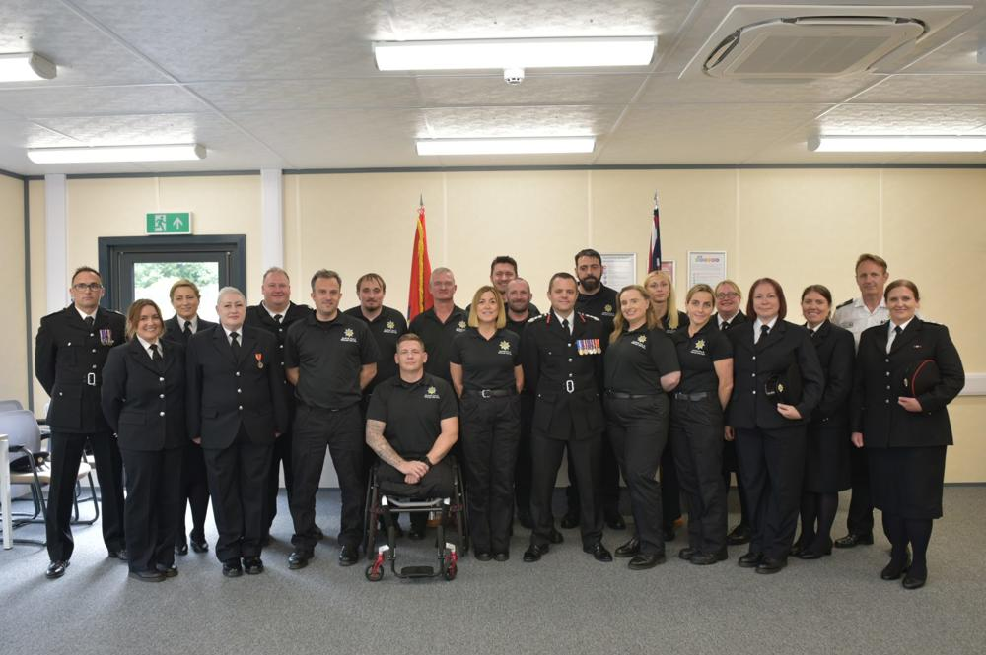Welcoming the new control room team following their pass-out parade; a ceremonial even
Formal Advertisement Of Undercliff Road East, Felixstowe ETRO
Formal advertisement of Experimental Traffic Regulation Order (ETRO) began on 23rd June.
The formal advertisement of the Undercliff Road East, Felixstowe, Experimental Traffic Regulation Order (ETRO) will start on the 23rd June. On that date, notices will be placed along the length of the site and be in place for six months.
The ETRO will come into effect on the 7th July 2025 and will operate as an experiment for a period of up to 18 month. Suffolk County Council will monitor the experiment and will consider in due course whether the provisions should be made permanent or alterations made. During the six month consultation period commencing immediately after orders come into effect, anyone may object to any provisions of the order and make any other representations.
Objections and other representations must be made in writing to Suffolk County Legal Services at Suffolk County Council, Endeavour House, 8 Russell Road, Ipswich, IP1 2BX, or emailed to rhea.phillip@suffolk.gov.uk, by the end of the 11th January 2026, and must state the grounds on which they are made. Please note that any such correspondence cannot be treated as confidential and maybe inspected by interested parties.
Copies of the order and maps showing the lengths of roads affected, together with Suffolk County Council's reasons for the experiment, can both be viewed on request at Felixstowe Library.
Please note that Suffolk County Council is considering modifying the order within the next few weeks to alter certain restrictions in the vicinity of the Fludyers Hotel. An update on this will be provided in due course which will include any extension to the consultation period that may apply.
£8m funding for Bus Service improvements
Suffolk County Council has secured a grant of £8m from the Department for Transport for new and enhanced bus services in the county.
The funding from the Department of Transport’s Local Authority Bus Grant can be used to create new bus services or enhance existing routes.
Following on from previous grants from the Department for Transport to improve bus services, totalling £3.7m of revenue funding between 2023 and 2025, the new grant which has been allocated for 2025/26 comprises of:
- £2,805,076 revenue for delivering new or enhanced services.
- £5,229,805 capital for new and improved bus stops, bus stations, bus priority measures or vehicle upgrades.
This money will enable Suffolk County Council to invest up to £5 million in capital projects to increase bus priority on congested streets, make improvements to bus stops and gain a better understanding of the journeys people are taking, paving the way for more innovative fare offers in the future. The council also plans to upgrade the current Real Time Passenger Information system, giving live updates on when buses will arrive at stops across the county.
The remaining £2.8 million will be spent supporting the existing services on the county’s bus network and working with bus companies to finalise a number of route improvements and new services, set to launch later this year.
The previous funding has created and enhanced more than 15 routes across the county, through the council’s Bus Service Improvement Programme (BSIP). These included the first Sunday and evening service between Sudbury and Bury St Edmunds for more than 20 years and direct links from Haverhill and Mildenhall to the West Suffolk Hospital.
Successful bids will be contacted in the coming days with new and enhanced services coming online later this year.
We have seen the positive impact from the previous BSIP funding and our close work with parish councils and local community groups, to enhance and set up new bus links – in many cases the first links in many years allowing people to access goods and services using public transport.
Cllr Chambers continued: “This new round of funding will enable us to continue to improve bus journeys in the county and support our ambition to help make public transport a viable alternative to the car for more Suffolk residents.
“We are also aware of the recent cancellations of services in Newmarket and Marham Park, and we are working with local providers and the community to find solutions, utilising the funding from Department for Transport. We have an excellent track record of supporting services when needed and hope to reach a solution soon.”
A full list of enhanced and new services funded with the previous BSIP funding can be found at: Bus Service Improvement Plan - Suffolkonboard including videos from services who received BSIP round 1 funding.
Details of successful bids for the latest round of funding will be posted on Suffolk On Board.
Shop closed for selling illegal tobacco and vapes
A Suffolk store has been ordered to close for three months following a pioneering joint operation by Suffolk County Council Trading Standards and Mid Suffolk District Council to tackle the sale of illegal tobacco and vapes.
This is the first closure order in Suffolk granted by the courts for the sales of illegal tobacco or vapes from a business.
Initial action began back in November 2023, when Trading Standards officers seized illegal tobacco hidden under the counter during an inspection of the newly opened store. Two further inspections during 2024, supported by Suffolk Police and using tobacco detection dogs, revealed hidden concealments were being used to hide illegal goods on site. In total
134 pouches of hand rolling tobacco, 463 packets of illegal cigarettes, and 458 illegal vapes were found and seized.
Following engagement with the landlord, there was a change in tenant, however further test purchase operations conducted by Trading Standards in late 2024 and early 2025 confirmed Star Convenience was still selling illegal tobacco.
In light of this persistent criminal activity, Mid Suffolk District Council and Suffolk Trading Standards successfully applied for a three-month closure order, which was granted by the courts to protect the local community and prevent further harm.
Councillor Steve Wiles, Suffolk County Council’s Cabinet Member for Public Protection, said:
“This closure sends a clear message that we will not tolerate the sale of illegal tobacco or vaping products here in Suffolk.
“These items are not only harmful to resident’s health, but they also undermine legitimate local businesses and fund organised crime. I commend the work of our Trading Standards team and partners in bringing this case to a successful conclusion.”
Graham Crisp, Head of Suffolk Trading Standards, added:
“Our officers have uncovered repeated and deliberate attempts to conceal illegal goods, including the use of hidden compartments and persistent unlawful trading. The sale of illegal tobacco and vapes puts the public at risk and damages community trust.
“This Closure Order is the result of thorough investigation, community intelligence, and partnership working. It is the first one in Suffolk for such activity and we will be seeking to use this powerful enforcement mechanism much more in the future to tackle and prevent the sales of illegal tobacco and vapes”
Leader of Mid Suffolk District Council, Cllr Andy Mellen, said:
“I am delighted that by working with Suffolk Trading Standards we have been able to demonstrate our council’s zero-tolerance approach to the sale of illegal and potentially dangerous tobacco and vapes.
“We will continue to take all possible steps to protect our communities from crime and anti-social behaviour, while supporting legitimate traders on our high streets.”
Report the sales of illegal tobacco and vapes to Trading Standards via Citizens Advice Consumer Service on 0808 223 1133.

TJ July 2025

Useful links etc:
https://national-infrastructure-consenting.planninginspectorate.gov.uk/decision-making-process-guide
https://national-infrastructure-consenting.planninginspectorate.gov.uk/having-your-say-guide
https://national-infrastructure-consenting.planninginspectorate.gov.uk/projects/EN020026
https://national-infrastructure-consenting.planninginspectorate.gov.uk/projects/EN020026/project-updates
Video https://infrastructure.planninginspectorate.gov.uk/video-transcript-six-stages-of-the-national-infrastructure-planning-process/
YouTube video: https://www.youtube.com/watch?v=4COj1N0kbfA

Sizewell C MSD forum
My Questions submitted to the MSD forum for the 2nd July – please note that these may be shortened for the chair, however, I thought you may appreciate seeing my questions in full.
Question 1)
Although probably better suited to the community forum, a deadline for application is looming. It would be most useful to have an answer at the MSD forum and receive an update about the changes, any improvements and findings at the next community forum please.
I have received communications and comments from applicants about some of the last-minute issues that they have experienced in applying for a grant, especially in the last few hours before a looming deadline. It is important that any applicant should not be put off or nervous at any stage about applying. These grants are after all born out of the works being conducted by MSD etc.
While due diligence is undoubtedly necessary to ensure that public or charitable funds are distributed ethically and to responsible organisations, there is a delicate balance to be struck. Is it appropriate for the SCF personnel to be questioning the content and governance documents and recommending changes to policies and procedures?
Trustees of local councils and charities typically operate under well-established governance frameworks, often adhering to industry standards and protected by Trustee Insurance. When grant administrators begin scrutinising and proposing amendments to such foundational documents, it not only risks undermining the autonomy and expertise of these organisations but could also inadvertently expose applicants to new legal uncertainties or liabilities. The expectation that applicants should alter standardised, often legally vetted, policies in response to the preferences of a grant officer does not seem proportionate to the scale or purpose of

community grants. It would be helpful for the SCF team to clarify why such granular oversight is deemed necessary, and whether alternative approaches might better respect the knowledge and governance structures already in place within applicant organisations.
It was my understanding that these grants should not be too difficult or cumbersome, enabling applicants at all levels.
What measures could be implemented to streamline the grant application process and reduce administrative barriers for volunteer-led organisations, especially considering the challenges and stringent requirements currently encountered by applicants?
Question 2)
Please provide an update on the volume of water being brought to site, the uses this is being put to and where this is being sourced/transported from? And which route do vehicles use to and from the site?

Reminder.
Dear parish council colleagues,
Thank you to those who were able to attend one of Suffolk County Council’s recent parish council briefing sessions to discuss our response to the Government's proposal for local government reorganisation in Suffolk.
On behalf of our presenters Cllr Matthew Hicks, Cllr Richard Rout, Nicola Beach, Andrew Cook and Andrew St Ledger, we’d like to take this opportunity to thank you for your feedback throughout these meetings. You have provided invaluable input that will support the development of our proposal.
If you were unable to attend our local in-person briefings, we are also hosting three online sessions over the coming weeks. These sessions are primarily for parish council clerks and chairs, but if you would like other members of your parish council to attend then you are very welcome to book them a ticket too.
To reserve a space, please select one of the below dates:
- 7 July 2025
- 11 July 2025
- 16 July 2025

Additionally, we have recently launched our residents’ survey to capture the views and opinions of the people of Suffolk, providing them with the opportunity to have their say on our proposal at this very early stage.
The survey will run until 11.59pm on Monday 4 August 2025 and can be completed by visiting: www.onesuffolkcouncil.co.uk/residents-survey We would very much appreciate you help is sharing this survey with your residents so that we can reach as many people as possible.
If you have any further questions, please email communications.team@suffolk.gov.uk
Kind regards,
The Communications team
Suffolk County Council

