A very short and bland report this month as Cllrs are all within the moratorium period. You may wish to note the weed treatment target dates for your information boards and websites. Please keep yourselves updated regarding Sizewell C via their works tracker https://www.szcworkstracker.co.uk/ and also regarding roadworks etc on the one network app https://one.network/
The annual report has also been emailed alongside to this report for your annual town and parish meetings. Please note that my locality and local highways budgets have been fully spent/allocated (list of locality budget is included at the end of this report)
Best wishes,
TJ
Thank you to everyone that contributed towards the latest hearings regarding the Sea Link DCO. Like many other residents the County council continues to highlight issues with Sea Link energy project
The examination of National Grid’s Sea Link project continues, with Suffolk County Council addressing serious concerns about access routes, the converter station, and for residents in Whitearch Park residential home near Benhall.
At the first opening hearing in November 2025, the county council maintained its long-standing position that development consent should not be granted, and it continues to object to the Sea Link proposals.
At this latest hearing, the county council outlined where improvements need to be made, and where details remain lacking with the National Grid’s proposals:
- Fundamental flaws remain with Benhall Bridge, including impacts on heritage, landscape, and the local community
- Significant concern for the safety and wellbeing of Whitearch Park home residents, especially around maintaining access during construction
- No expansion of the Order Limits at the converter station site to allow for improved mitigation planting and a public right of way
- The access route is not suitable and the county council has submitted details of an alternative access route for the project, arguing it offers greater long term robustness and fewer adverse impacts
It is regrettable that the issues raised by both the county council and local communities have not been given the attention they deserve. Through the examination process, we will continue to put our evidence directly to the Planning Inspectorate for the benefit of Suffolk residents.
We recognise that the applicant has made some modifications to their submission, but it still falls far short of what we would expect – particularly to protect local residents, highways infrastructure and the landscape. Our fundamental concerns about the Benhall Bridge, the crossing over the River Fromus and National Grid’s flawed transport strategy all remain. There is clearly a better access route to the site and we made this case to the examining authority,
It is regrettable that the issues raised by both the county council and local communities have not been given the attention they deserve. Through the examination process, we will continue to put our evidence directly to the Planning Inspectorate for the benefit of Suffolk residents.
Finally, turning to the modifications to the scheme at the Friston Substation site, whilst these are welcome improvement in terms of alignment between projects, the Council has submitted to the examination in REP5-181 a table setting out how the DCO wording needs further amendment to ensure that the benefits of the safeguards secured by the existing Scottish Power Renewables consent are fully transposed into the Sea Link DCO.
SCC have worked with Friston Parish Council on this issue and would like to take this opportunity to thank the Parish Council and Mr Michael Mahoney, in particular, for working constructively with the Council on this issue.

Government decision on energy projects could threaten Suffolk communities
Local communities could suffer at the hands of large energy infrastructure projects, as the UK government looks to push schemes through more quickly and take away powers from local authorities.
Published: 23 Mar 2026
Suffolk County Council is opposing the Sea Link project.
Government is planning to overhaul the nuclear system to speed up building, strengthen national and energy security, cut costs, and not get “bogged down in processes”, as described by the Prime Minister.
In response to a report by the Nuclear Regulatory Taskforce, government has accepted a recommendation to establish an in-house unit at the Department for Energy Security and Net Zero (DESNZ), to discharge Development Consent Order (DCO) requirements.
This is currently the responsibility of local authorities, who are best-placed to consider the impacts on local communities and local environment.
At a time when government is looking to increase the speed of delivery and reduce complexity of these projects. Taking this further, government is also minded to extend that approach beyond nuclear projects and electricity network projects, to all energy projects.
Suffolk County Council is concerned that this will in fact add layers of bureaucracy, slow down the process and put communities at risk of being ill-considered as projects are built.
Local communities rely on their local authorities to hold National Grid, and other energy developers, to account – something which Suffolk County Council has, and continues to do effectively. We can ensure that they are robustly protected when this critical national priority infrastructure is being built. Does DESNZ have the capacity and skills to deliver this work for multiple projects across the country? Or will it, as seems more likely, place additional burdens on local authorities to support this new layer of bureaucracy, with the cost falling on local taxpayers
Suffolk road schemes included in Government’s five year investment plan
The Department for Transport has announced schemes in Suffolk will feature in the next five year plan for trunk roads in England.
The government’s has announcemed its next five-year Road Investment Strategy (RIS) which features four key projects in the county.
The RIS is the Department for Transport’s investment plan for operating, maintaining, renewing and enhancing the strategic trunk road network in England.
Known as RIS3, it runs from April 2026 to March 2031 and in Suffolk sees:
A12 improvements at Woodbridge – a recommitment by the government to funding its share during this period of the £63 million scheme to upgrade the A12 between the Seven Hills junction with the A14 and the Woods Lane junction, subject to Suffolk County Council submitting the Final Business Case, anticipated for later this year.
A140 - A1120 Earl Stonham junction improvements – this has been classed as a scheme ‘recommended to continue’, where the government accepts work on developing improvements should go ahead during this period. However, this is subject to affordability, value for money and deliverability assessments.
The junction is an historic staggered crossroads where queuing traffic causes congestion. The improvement scheme would realign the eastern A1120 arm, providing more space for vehicles to queue and avoiding vehicle conflicts by simplifying the junction.
Two other schemes in Suffolk have been earmarked for progression.
They are improvements to the A11 Fiveways junction near Mildenhall and the A12/A14 Copdock interchange.
These will see the government and National Highways continue to develop but not deliver them during the RIS3 period.
Both schemes remain uncommitted and with no guaranteed funding, but it does mean they have a better chance of being included in the next RIS after 2031.
Both Copdock interchange- a key junction serving freight traffic bound to and from the Port of Felixstowe – and the A11 junction have suffered from problems of congestion and design flaws.
Full details of the scheme can be found on the Department for Transport website.
New integrated passenger information board goes live at Ipswich railway station
Bus timetables now sit alongside rail arrivals and departures to help passengers plan their journeys.
Passengers at Ipswich railway station are now benefiting from a new large-format information screen, designed to make it easier to plan journeys and stay up to date while travelling.
Installed through a partnership between Greater Anglia and Blackbox Company, and funded and supported by Suffolk County Council, the new screen provides real-time train departures, onward bus connections, and clear updates during disruption, all in one place.
The screen has been installed near the main entrance at Ipswich railway station. (Picture: Greater Anglia).
The 4.8 metre-wide display uses high-resolution LED technology to ensure information is clear and easy to read from across the concourse, helping customers quickly access the information they need, whether catching a train or continuing their journey by bus.
The installation also features the new UK railway clock, a modern interpretation of a classic railway symbol, appearing at a Greater Anglia station for the first time.
The Ipswich screen builds on the successful introduction of a similar system at Norwich station in June 2025.
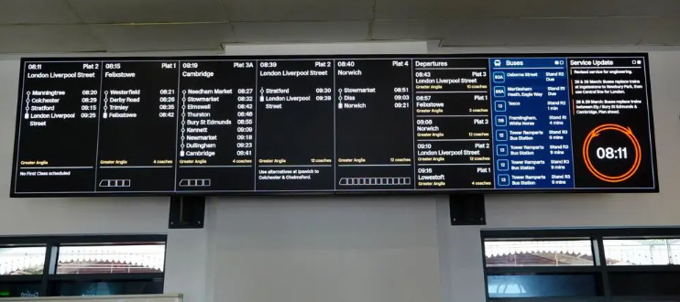
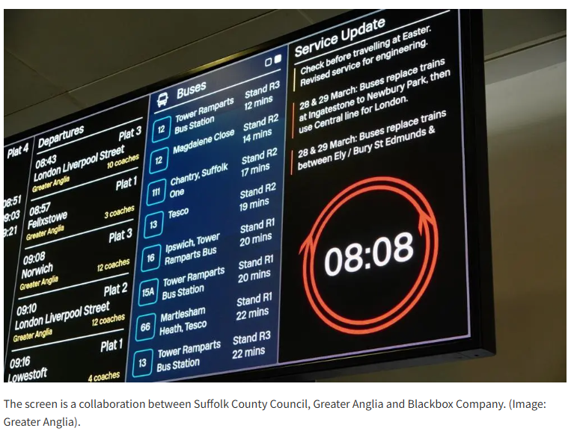
The screen is a collaboration between Suffolk County Council, Greater Anglia and Blackbox Company. (Image: Greater Anglia).
Andrew Goodrum, Greater Anglia’s Infrastructure & Major Projects Director, said: “We are pleased to introduce this new screen at Ipswich, which will make it easier for customers to access clear, real-time travel information in one place.
“It’s another step forward in improving the overall experience at our stations, particularly during busy periods or when services are disrupted.”
Suffolk County said: "This simple coordination of timetable information empowers passengers to plan seamless journeys and reduce the stress of missed connections. Travellers no longer need to juggle multiple apps, timetables, or guesswork; instead, they can make confident, well-timed decisions in one place. It helps make public transport a much more integrated and coherent system. Whether someone is commuting to work, heading to school, or visiting the town centre, the clarity and convenience of having both bus and rail details side by side encourages greater use of sustainable transport."
Gavin Russell, CEO of Blackbox Company (UK), said: “We are proud to continue pushing the boundaries of passenger information in partnership with Greater Anglia.
“Since introducing the first colour display on the network in 2017, our focus has been on improving the passenger experience by making information clearer, more integrated and more responsive to real-world operations.
“Through the continued development of our Azzido Cloud platform and advances in LED technology, the Ipswich installation represents another step forward in delivering a truly connected and intuitive information environment.”
Government announces outcome of local government reorganisation in Suffolk
The government has announced its decision on Local Government Reorganisation (LGR) in Suffolk in 2028, opting for three unitary authorities. Published: 25 Mar 2026
The government has announced its decision on Local Government Reorganisation (LGR) in Suffolk in 2028, opting for three unitary authorities – despite clear evidence that this is not the best outcome for Suffolk.
This is a major milestone in the future of local government in the county and reshapes how councils are structured and how services are delivered across the county.
Each of the three new unitary councils will cover their own new geographical area: West Suffolk, East Suffolk, and South Suffolk and Ipswich.
The creation of three unitary authorities for Suffolk will mean the abolition of all Suffolk’s councils:
- Suffolk County Council
- East Suffolk Council
- West Suffolk Council
- Babergh and Mid Suffolk Councils
- Ipswich Borough Council
While detailed boundaries are still being finalised, the creation of three unitary councils, West Suffolk, East Suffolk, and South Suffolk and Ipswich, means that from May 2028 the new councils will replace the following:
- West Suffolk: West Suffolk Council, as well as parts of Babergh and Mid Suffolk Council
- East Suffolk: East Suffolk Council, as well as parts of Mid Suffolk Council
- South Suffolk and Ipswich: Ipswich Borough Council as well as parts of Babergh Council, and East Suffolk Council
Elections for the new shadow authorities will take place in May 2027, with the new councils formally taking over responsibilities from May 2028. This transition period will enable detailed work for reorganisation to take place, and services will be delivered as usual throughout the process.
Additionally, each new authority would be responsible for the delivery of the services previously undertaken by the County Council in their specific area. The new councils would have responsibility for delivering services including waste collection, planning, adult social care, children’s services, highways and more.

Bringing fire control back to Suffolk goes step further with new technology partnership
Suffolk Fire and Rescue has joined Norfolk and Hertfordshire in a new technology partnership to strengthen control room resilience during high-demand periods.
Suffolk Fire and Rescue Service has strengthened its in-county fire control room by joining a new shared technology partnership with Norfolk and Hertfordshire Fire Services - giving Suffolk extra capacity during unusually high demand and major incidents, if needed.
Unlike its previous collaboration model with Cambridgeshire Fire and Rescue, Suffolk’s fire control room remains firmly rooted in the county, using local staff, local knowledge and local decision-making every day. The new “Guardian Hub”, created by Motorola Solutions which provides the fire control systems for all three services, allows 999 calls to be shared instantly between the three services if demand spikes, giving Suffolk additional support at the busiest moments without losing the advantages of having its control room back home.
The cloud-based system links the three control rooms remotely, meaning major incidents, extreme weather and high call volumes can be managed more quickly and effectively across all three counties if needed.
For Suffolk, the hub builds on the progress already made since returning fire control to the county last year. Faster call handling, stronger links with crews and preserved local knowledge remain at the core of our service – now backed up with immediate mutual support during peak demand.
Jon Lacey, Suffolk Fire and Rescue Service’s Chief Fire Officer, said:
“Major incidents and times when the public need the fire service most can place huge pressure on control rooms.
“This hub gives us extra capacity instantly, without losing the local knowledge and quick decision-making that comes from having our control room back in Suffolk.”
David Shorland, UK and Ireland Sales Director at Motorola Solutions, said:
“Fire and rescue services are there for their communities, but the pressure they face continues to grow.
“Guardian Hub gives services a better way to connect, coordinate and respond. With agencies doing more with less, we’re delivering a resilient, scalable model to help protect communities.”
£3.9 million investment proposal to protect and enhance Public Rights of Way
SCC considered a plan to fund replacement or refurbishment of more than 700 structures across the county.
Suffolk County Council plans to invest nearly £4 million to improve and protect the public rights of way network.
The network, which provides more than 3,500 miles of off-road access for walking, cycling and horse riding, is supported by 3,770 structures including bridges, boardwalks, revetments and signposts.
A report to be considered by Suffolk County Council’s Cabinet on Tuesday March 24 said the £3.9 million investment will enable replacement or refurbishment of 735 priority structures, with a particular focus on bridges and boardwalks in central and coastal areas.
It follows a comprehensive condition survey where the council has identified a programme of improvements to replace or refurbish ageing structures.
The report says that over the next five years, 1,800 structures will need to be replaced or undergo major refurbishment.
Of these, 735 structures have been prioritised for 2026/27 and 2027/28 due to their known condition.
The structures are spread across the county, with the largest impact in the central and coastal area of Suffolk.
These are predominantly bridges but there are also a number of boardwalks on key coastal and estuary routes.
The cost of this two-year programme is £3.9 million in total - £2.05 million in 2026/27 and £1.85 million in 27/28.
The current budget for infrastructure maintenance is £225,000 a year, but since this figure was set in 2020/21 costs have risen by more than 50% for materials and contractors’ installation fees, as well as changes in specifications.
The proposed programme builds on recent successful projects delivered through additional capital funding, including major works at the Bailey Bridge between Walberswick and Southwold, Fen Bridge at East Bergholt and Hempyard Bridge in Ixworth.
The council’s investment plan comes at a time of significantly increased public use of the network.
Since the COVID-19 pandemic, customer reports have risen by more than 50%, with 3,411 reports received in 2025 alone.
By investing now, the Council aims to reduce the risk of route closures, avoid rising revenue costs and ensure the network continues to provide high-quality access for residents and visitors.
Temporary closures—required when structures become unsafe—cost around £1,200 each time and place pressure on the revenue budget, which also funds the county’s annual grass-cutting programme.
The planned capital investment will help prevent these costs and protect essential maintenance services.
It will also help to meet the council’s objectives for health and wellbeing, strengthening the local economy and providing value for taxpayers’ money.
The full report can be read on the Suffolk County Council website.

SPR Community Engagement event. Tuesday 21st April at the Thorpeness Country Club 2-7pm

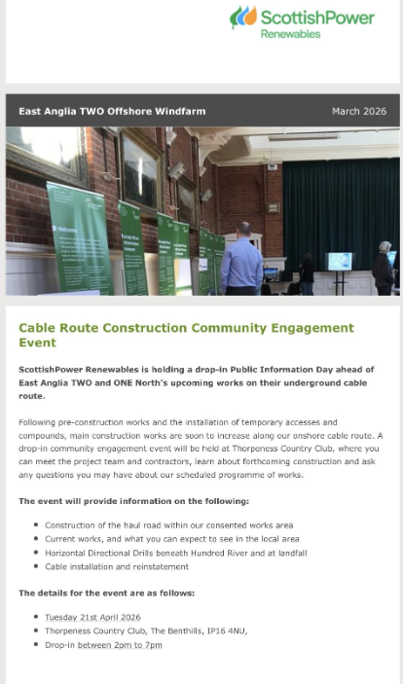

Weed treatment target dates:
1st treatments
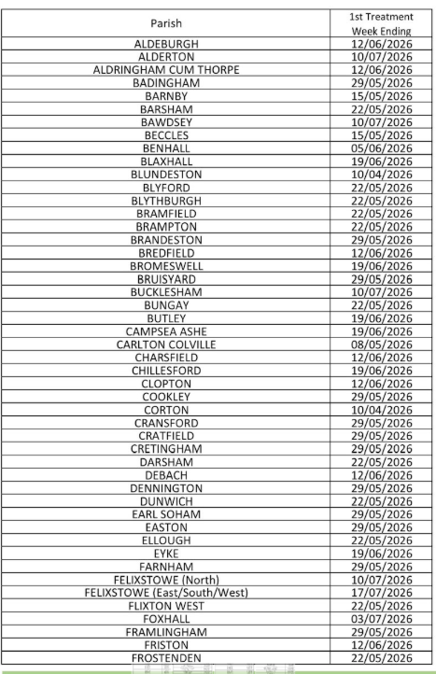
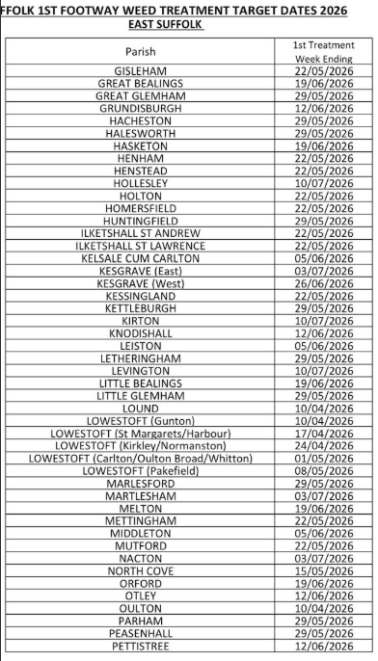

2nd treatment target dates:
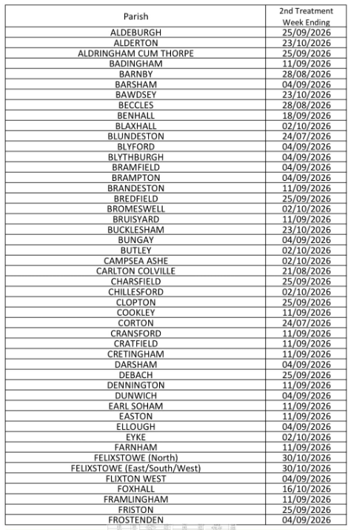
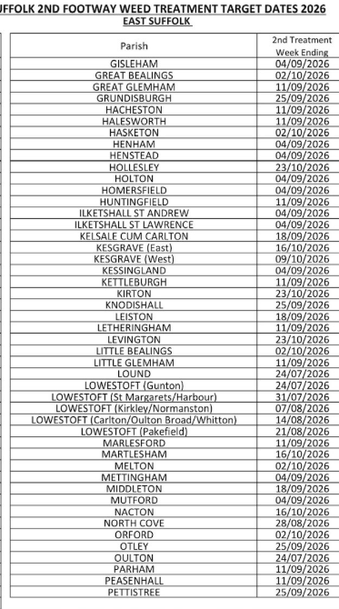
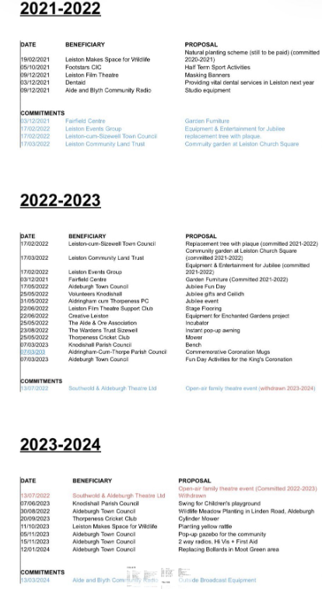
Please note the purpose of one being withdrawn was because the grant was not responded to by the applicant…
