KNODISHALL COMMON
COUNTRY WILDLIFE SITE
Suffolk Coastal 103
Knodishall Common lies to the west of Coldfair Green. The western section sits between Snape Road and the Hundred River with a smaller section on the other side of the river to the east. The Common has its origins as a pasture common, shaped by activities such as grazing, gorse cutting for fuel and other activities typical of the impoverished sandy soils of the Suffolk Sandlings. It supports a mosaic of valuable of lowland heathland habitat including areas of birch/sycamore woodland, gorse scrub, bracken open acid grassland, heather, lichen heath and bare ground. The Common is used for informal recreation and in the summer of 2022 a fire, which was started deliberately, destroyed much of the dense gorse scrub which has started to recover. The species recorded in the areas of acid grassland include common cudweed, mouse-ear hawkweed, sheep’s-sorrel, heather, subterranean clover, spring vetch, and heath bedstraw as well as Nationally Scarce species suffocated clover. The woodland and scrub provide opportunities for a range of both common and migratory bird species, including linnet, turtle dove and nightingale. The mosaic of habitats on site provides opportunities for a wide range of invertebrates including ground nesting bees and wasps. The areas of heather and open grassland are valuable for a range of butterfly species and small heath butterfly has been recorded. The presence of the Thorpeness Hundred River, which flows through the Common also provides habitat for aquatic inverterbrates and has record of water vole present. It borders the north and east giving connection to the landscapes beyond.

Knodishall Common County Wildlife Site boundary.
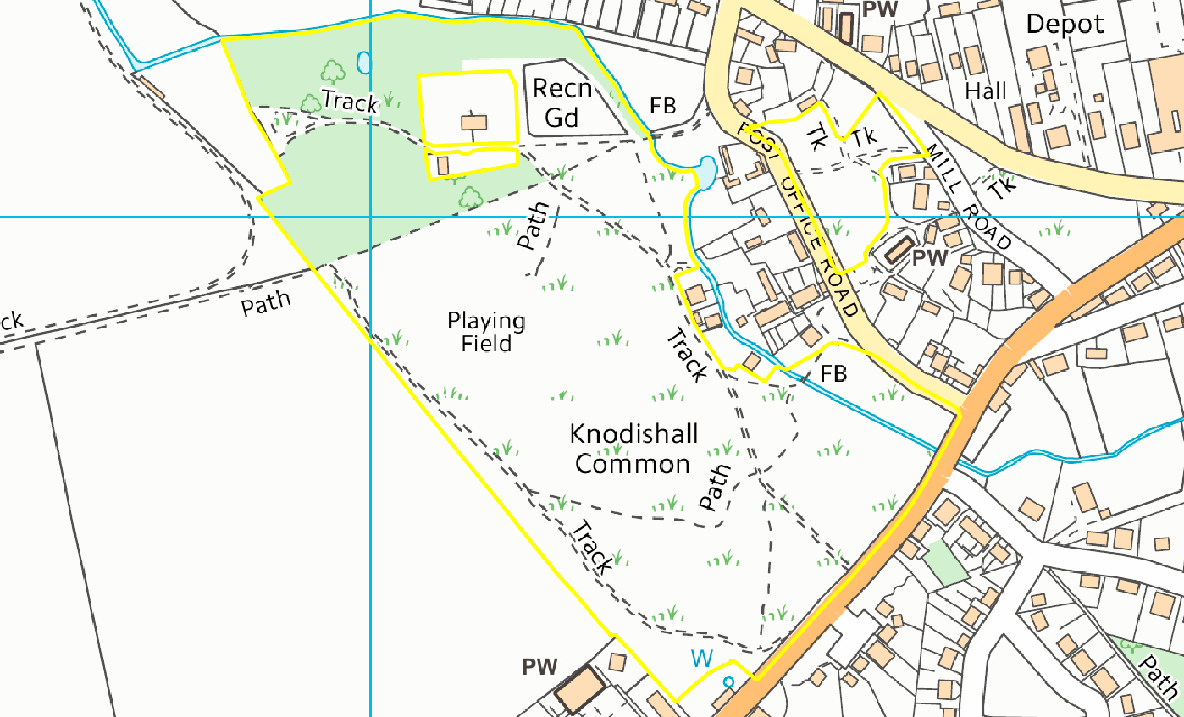

Priority and protected species recorded on and adjacent to site and submitted to Suffolk Biodiversity Information Services
Autumnal Rustic | Eugnorisma glareosa
Beaded Chestnut | Agrochola lychnidis
Brown-spot Pinion | Agrochola litura
Buff Ermine | Spilosoma lutea
Centre-barred Sallow | Atethmia centrago
Cinnabar | Tyria jacobaeae
Common Toad | Bufo bufo
Deep-brown Dart | Aporophyla lutulenta
Dunnock | Prunella modularis
European Water Vole | Arvicola amphibius
Feathered Gothic | Tholera decimalis
Grayling | Hipparchia semele
Green-brindled Crescent | Allophyes oxyacanthae
Hedge Rustic | Tholera cespitis
House Sparrow | Passer domesticus
Large Wainscot | Rhizedra lutosa
Linnet | Linaria cannabina
Norfolk Aeshna | Anaciaeschna isoceles
Powdered Quaker | Orthosia gracilis
Song Thrush | Turdus philomelos
Starling | Sturnus vulgaris
Streak | Chesias legatella
Swift | Apus apus
Turtle Dove | Streptopelia turtur
West European Hedgehog | Erinaceus europaeus
White Ermine | Spilosoma lubricipeda

